Jio Report

***Introduction:***

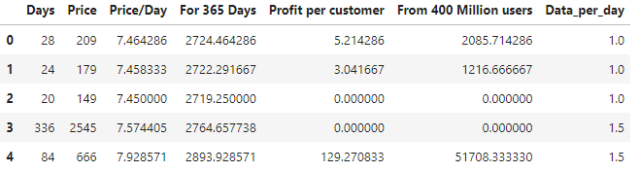 Jio is a telecommunication company. They wish to improve on their prepaid plans and have better strategic plans based on customer preferences. Understanding what the customer wants will lead Jio to have enhanced profitability as well as greater company growth. The goal will be to explore the following dataset provided by the company and predict how we can improve their existing prepaid plans so they can make more profit while satisfying the customers goals.

Figure1: Jio original dataset

This is original dataset for the Jio which shows the profitability they have achieved with the current data plans. The dataset consists of 7 attributes. Days represents the number of days in which the plan is valid. Price is the cost of the plan. Price/Day is how much the plan costs for a day. For 365 days is the total income for a year. Profit per customer is how much profit has been made based on the plan. From 400 million users tells us about the estimated data on roughly 400 million customers and lastly the Data_per _day is the total data that Jio offers per day.

***EDA:***

Let’s explore the datatypes of these attributes.

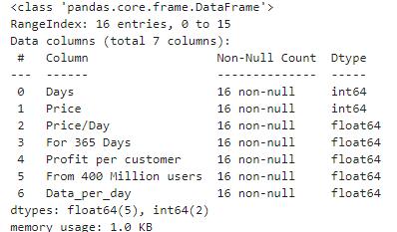

Figure2: Data types of the dataset

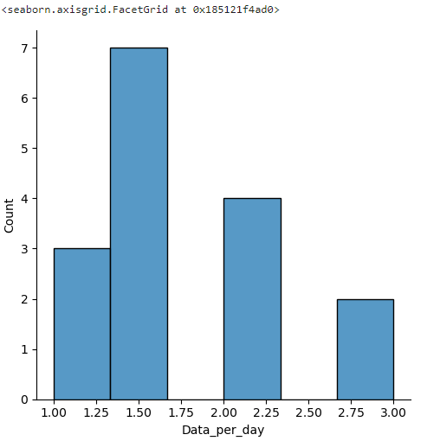We can see that there are 16 different data entries. I have not done any changes to the dataset since all this data is suitable for predicting the next move to improve profitability.

Figure 3: Data per day comparison

Based on this bar graph, we can see that Jio has 4 different data plans. The 1.0Gb, 1.5Gb, 2Gb and 3Gb. The count tells us how many of the data plans have been sold. It seems like 1.50Gb has been sold more than the remaining data plans available. One reason is that the price for 1.50Gb is around 7-8 Rs per day, which is very reasonable. The other reason is due to customer preference. Most people use data plans for emergencies like checking emails when they are outside or for navigating. In which case it’s a better deal. When we look at 1Gb data plans we can see that not a lot has been sold it sold less than the 2Gb. Part of the reason for this is because the price per day for 1Gb is slightly less than 1.5Gb. in which case its better to go for the 1.5Gb since an upgrade for the literally the same price. 2Gb has got 4 sales which is good which tells me that more people are willing to buy this data plan in the future. 3Gb seems to be targeted to people with a heavy usage. It’s the most expensive but has got more days and more usage.

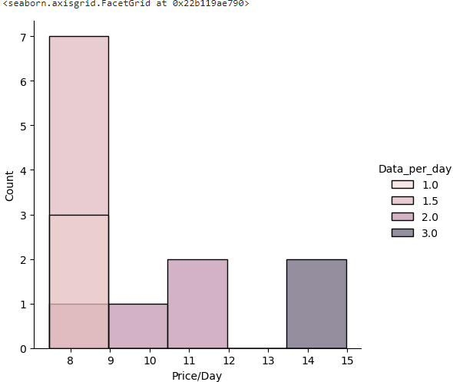Figure 4: Price/Day with respect to data_per_day

Based on this graph, we can see that the cheapest plan coats roughly 8 Rs which is represented by 1 and 1.5Gb data plans. The most expensive one is roughly about 15 Rs which is represented by the 3 Gb data plan. We can also see the 1Gb plans and 1.5 Gb plans shares the same prices. We can see the overlapping on the first bar. The 2Gb has two different price ranges we show us that one of them provided data for less days while the other provides for more days. The 3Gb plans is by itself with no abnormalities.

***Conclusion:***

Based on what we have seen, we can make a couple of improvements on Jio sales as well as improve on their profits. Firstly, looking at figure 4 we can see that the 1 and 1.5 Gb data-per-day are overlapping with each other in terms of their cost. This means that 1 and 1.5 Gb share the same prices in some days. Due to this, customers would obviously buy the 1.5 Gb more than 1Gb since its offers way more. Thus, reducing the profits for the 1Gb data plans. We can fix this issue buy reducing the cost the 1Gb plan to like roughly 4-5 Rs/day and keep the cost of the 1.5Gb the same. This will ensure more profitability as well as satisfy customers requirements. If there is one thing the customers like is affordable prices. I would also recommend to create more data plans every year so that the market can attract more customers as well improve on their profitability. In the future, I would like to work on how we can increase the profitability even more effectively.